[D3c] Find information about a specific application
Best path for a citizen to find an application near their residence: cityview Portal
Step #1 - click on this link - https://cityview.ci.bend.or.us/Portal/
Step #2 - scroll down to “planning and historic”
Step #3 - click on “application search”
Step #4 - The next page gives the user several options:
- Search box where the user types in a project name or number, address or tax lot
- click on the “find applications near me” tab and use the interactive map to zoom in and move to your location.
Best path for a Land Use Chair: The Community Development Data Explorer
In conjunction with replacing ePlans with CityView, the city has created an interactive mapping tool called Community Development Data Explorer which allows for a wide range of research capabilities on active (and applications made within the last ten years. This tool was made public in January 2021 and will be improved upon as the public provides feedback to the staff responsible for its development. This interactive mapping tool is one of eight tools within the “Interactive Mapping Gallery.” Here is a description of this tool.
Step #1 – The gallery can be found at: https://bendoregon.maps.arcgis.com/home/index.html
Step #2 - Scroll down and click Community Developer Data Explorer.
Step #3 - Then Planning app Viewer on toolbar at top of page. On the next page is a screenshot of what should then download.
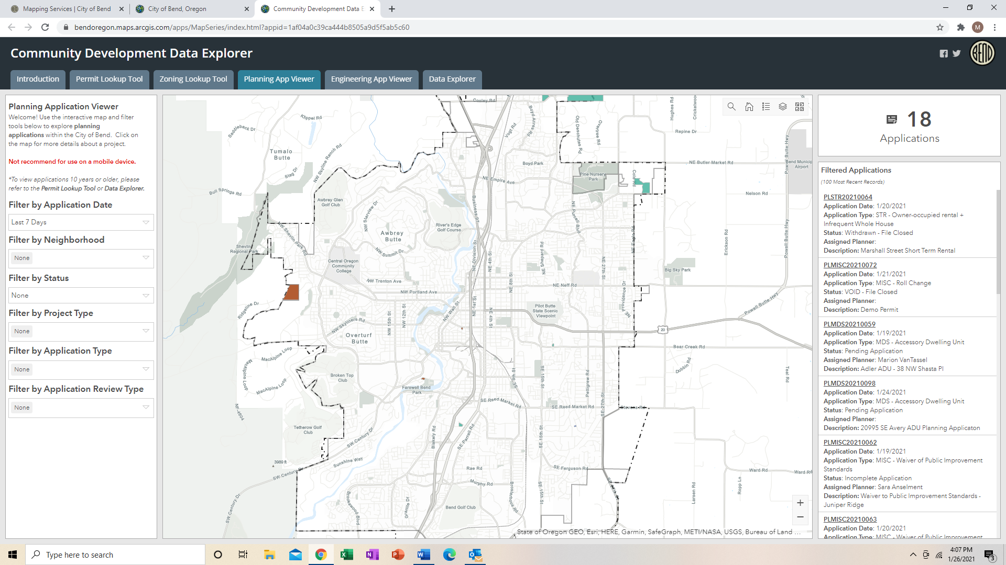
There are six different “filters” on the left margin where settings are used to base a variety of different “searches” on. For example, the first filter allows the user to set the time period. The default is seven days. There is a filter for narrowing the search to only your NA. There is a filter for a specific application type.
On the right margin is the total number of applications filed (with this example, 18) in the last seven days. Below the total number of applications, the list of all 18 applications that can be scrolled through.
By clicking on any one of the underlined permit numbers, the map immediately zooms in on the location of the selected application and a window drops down which provides specific information on the selected application.
If a larger time period is selected, more than one application may be accessible for the parcel. This tool’s data comes from active applications being applied for in the CityView platform and older data from the ePlans platform.

